**COMSATS University Islamabad, Lahore Campus**

**🗹 Mid Lab Examination Spring 2024**

|  |  |  |  |  |  |
| --- | --- | --- | --- | --- | --- |
| Course Title: | Artificial Intelligence | Course Code: | CSC462 | Credit Hours: | 4(3,1) |
| Course Instructor/s: | M.Taimoor Akmal | Programme Name: | BCS | Maximum Marks: | 25 |
| Time Allowed: | 90 Minutes | Date: | 01-04-2024 | | |
| Student’s Name: |  | Reg. No. |  | | |
| **Important Instructions / Guidelines:**   * Attempt all questions. * Show all your work for partial credits. Please be neat. * Upload your solutions in Google Classroom. | | | | | |

**Question 1: CLO: <6>; Bloom Taxonomy Level: <Applying>. [12.5 marks]**

**Implementing BFS   
  
Scenario:**

You are an adventurer exploring a mysterious land represented by the given graph. Each node represents a location, and each edge represents a path between two locations. Your goal is to find all possible paths from the starting location (node A) to the hidden treasure (node J). However, the land is full of dangers, and you can only traverse each path once. You must use **Breadth-First Search (BFS)** to explore the land and find the path to the treasure.  
  
**Graph:**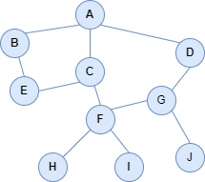

**Sample Input/Output:**

Path from Location A to F is:

**A -> C -> F**

**Hints:**

1. Start at node A and use BFS to explore the graph.

2. Maintain a queue to keep track of nodes to visit and a path to each node.

3. When exploring a node, add its neighbours to the queue with the current path plus the neighbour.

4. Stop when you reach Goal node or when there are no more nodes to explore.

5. If goal node is reached, you have found the path from start to goal.

**Question 2: CLO: <6>; Bloom Taxonomy Level: <Applying>. [12.5 marks]**

Consider the following directed graph representing a network of cities connected by roads, along with the cost of traveling between each pair of cities:

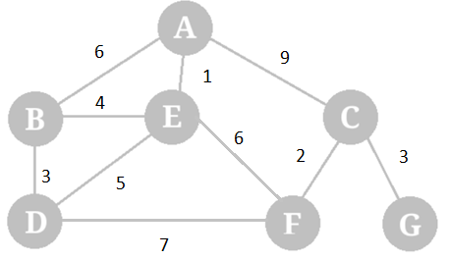

Assume that the heuristic values for each city (estimates of the cost to reach the goal city 'G') are as follows:

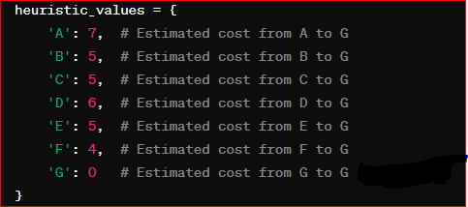

You are starting at city 'A' and want to reach city 'G' using the A* search algorithm.

**Question.** What is the path from city 'A' to city 'G' and its total cost?